Part 1: Variables and Scope

1. Explain how var works in JavaScript. What is variable hoisting? Give a code example.

Var: is used to declare a variable with global scope or functional scope.

The variable that declared using var inside the function can’t be used outside this function.

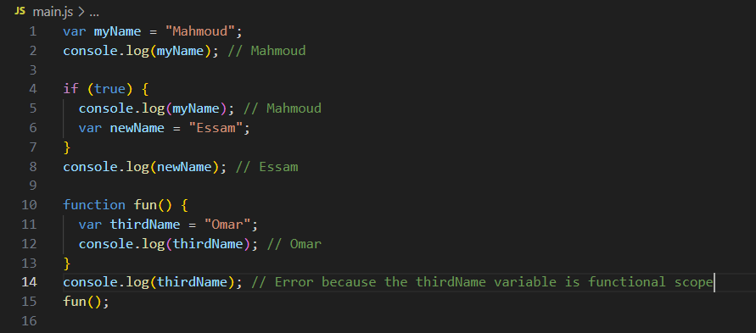

Variable Hoisting: is to make the variable that declared using var keyword to be assigned to undefined if we declare the variable without **initializing** it, so it will work.

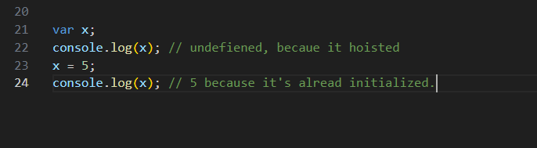

2. What is the scope of a variable declared with var inside a function? What about inside a block (e.g., an if statement)?

The scope of the variable that declared inside a function using var is only inside the function .

The scope of the variable that declared inside a block using var is global.



3. List all JavaScript primitive types in ES5. Give an example of each.

Number null string undefined Boolean

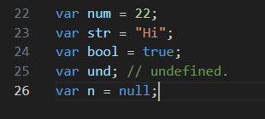

4. What is the difference between a primitive type and an object type? Give an example where this difference is important.

|  |  |
| --- | --- |
| Primitive type | Object type |
| Value | Reference |
| Stored in stack | Stored in heap |
| Copied by value | Copied by reference(pointer) |

This difference is important when passing by value or by reference and also reassigning value to variables.

5. Create a number, string, and boolean using both literal and constructor syntax. Show the difference in their types using typeof.

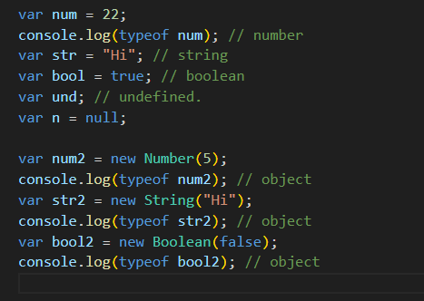

6. Why is it generally recommended to use literals instead of constructors for primitive types?

To be easy to reuse these variables with coping and also with passing to functions.

7. Given the following code, what will be the output? Explain why.

var x = 123.4567;

console.log(x.toFixed(2)); // 123.45

/// becaue toFixed function used to get specific numbers after the decimal point.

console.log(x.toPrecision(4)); // 123.4

/// because toPrecision used to get specific number including the integer part.

8. What is NaN? How can you check if a value is NaN? Give an example.

NaN: refers to not a number

To check it we use is NaN

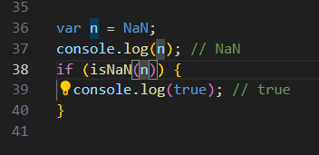

9. What is the difference between parseInt, parseFloat, and Number? Give an example for each.

paresInt used to cast (Explicit) to integer

paresFloat used to cat(Explicit) to float

10. What is the difference between implicit and explicit type casting? Give an example of each.

Implicit casting: is the type of casting that the computer is responsible for it which happen in the run time like adding int with float the result will be float, or dividing two int numbers the result is float.

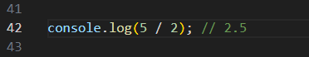

Explicit casting: is the type of casting that the developer is responsible for like using paresInt or paresFloat

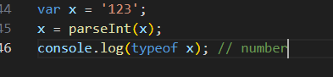

11. What will be the result and type of the following expressions? Explain your answer.

- true + 5 = 6 // the js will implicit cast the true to 1 and add it to 5 to get 6

- "10" – 2 = 8 // The js will implicit cast the “10” to number and make the math expression

- 12 - "1a" = NaN // The js will try to cast eh “1a” using number which will return NaN and any

Math expression with NaN will return NaN

- 5 / 0 = Infinity

- 5 + undefined = NaN

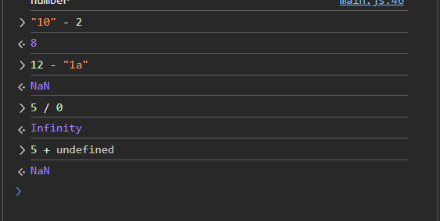

12. What will be logged to the console in the following code? Explain each step.

var a = "15.5";

var b = +a;

console.log(b, typeof b);

15.5 number

// as the +a will do casting to the variable a and make number, then assign this number value to b variable

13. What will be the output of:

var result = 20 > true < 5 == 1;

console.log(result);

// true

Explain why.

// because 20 > true will return true after casting true to 1

Then true < 5 will be true.

Then true == 1 will return true at the end as true will be 1 after casting .

14. Write a function that takes a string and returns true if it can be converted to a valid number, and false otherwise.

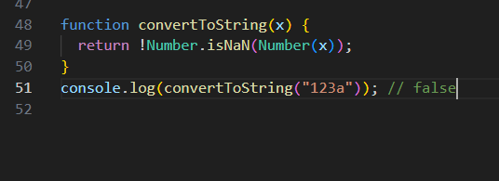

15. Write a program that prints all numbers from 1 to 20 using a while loop.

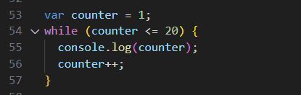

16. Write a program that asks the user to enter numbers until they enter 0, using a do...while loop. After the loop ends, print the sum of all entered numbers (excluding 0).

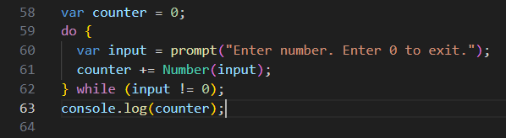

17. Write a program that takes a number from 1 to 7 and prints the corresponding day of the week using a switch statement. Use a for loop to test your program with all numbers from 1 to 7.

